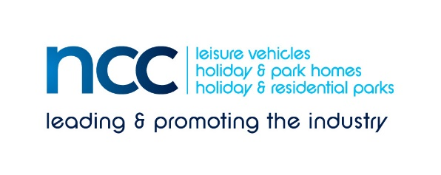
PRESS RELEASE - immediate
18 November 2020
NCC warns the latest deadline for the transition to greener vehicles could lead to a complete lack of affordable motorhomes and tow cars, with unintended consequences
The National Caravan Council (NCC) is extremely concerned by today’s announcement that government will bring the ban on the sale of new diesel and petrol vehicles forward to 2030 – less than 10 years away - and hybrid powertrains will only be allowed until 2035.
To achieve an affordable range of tow cars capable of pulling a family-sized caravan, and an efficient all-electric engine suitable for motorhomes weighing 3,500 kg (or more) in these timescales remain huge technical challenges.
There are currently in the region of one million consumers who caravan annually, forming one of the mainstays of UK domestic tourism – this has been particularly evident this year. If their leisure pursuit is no longer practical or affordable, the highly undesirable unintended consequences could include:
- Older vehicles are not replaced, leaving less environmentally friendly vehicles on the road longer.
- Caravanners exit the market, instead choosing to fly long haul or to cruise; both types of holiday create more emissions than a typical touring holiday in the UK.
- A significant reduction in UK domestic tourism receipts – the average caravan holiday generates £557 per visit (£101 per day).
Leisure vehicle (touring caravan and motorhome) manufacture has been a British manufacturing success story – both could be seriously affected. These small/medium businesses do not have the resources to invest in research themselves.
Motorhome manufacturers/converters are reliant upon larger base vehicle manufacturers, who with this truncated timescale, are unlikely to prioritise motorhomes over vans and other product types. Similarly, the ability of an electric vehicle to successfully tow will not be at the top of the priority list as car manufacturers struggle to meet this challenging deadline.
While the NCC, and the leisure vehicle industry, support moves towards a zero emissions future, there are so many barriers in the way of achieving this – arguably far more obstacles for motorhomes and tow cars than for other vehicle types.
NCC Director General John Lally commented: “The development of electric motorhomes and tow cars may on the surface seem a niche market. However, it is a very valuable market in terms of the UK’s tourism offering and one that we would like to see Government supporting by confirming that funding will be made available for manufacturers to develop a series of lighter vehicle chassis on which to build motorhomes and campervans.
“Manufacturers of electric cars need to be encouraged to ascertain and state the vehicle’s towing capacity. Grants will be needed to install the infrastructure necessary, for example on holiday parks in rural areas, to enable multiple fast-charging points for holidaymakers.
“We therefore need to know how government plans to fulfil its ambitions in a realisable way, while safeguarding industry and jobs in manufacturing, supply and tourism”.
A further final concern of the NCC is that the UK must remain competitive in Europe; UK Regulations must not place British manufacturing at a disadvantage as the end of the transition period approaches.
Ends
Editors’ notes
The NCC is the UK trade association representing the touring caravan, motorhome, caravan holiday home and residential park home industries. More information at www.thencc.org.uk
There are currently 520,000 touring caravans in use in the UK – and a far greater number of tow vehicles.
Of the 228,000 motorhomes registered in the UK, the vast majority have diesel engines. Because they travel an average of 2-3,000 miles a year, their lifespan is often far longer than that of a car or van.
For more information on the value of caravanning and the parks industry to UK tourism, see https://www.ukcca.org.uk/

Press contact: Louise Wood, louise.w@thencc.org.uk
Tel 07824 994690

