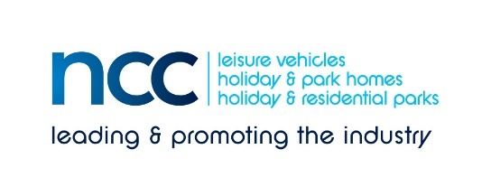
28 May 2020
PRESS RELEASE – immediate distribution
Motorhome and touring caravan dealerships in England to re-open on 1 June
The NCC is delighted to be able to confirm that leisure vehicle dealerships and distributors will be permitted to re-open, along with certain other non-essential retail businesses in England from next Monday. This is providing the businesses adhere to social distancing and hygiene protocols and have undertaken suitable risk assessments.
The NCC says that it is working with member dealers to deliver industry guidance and best practice and to re-assure potential customers. NCC Director General John Lally says: “We are delighted that our lobbying efforts paid off and we are so very grateful to all those MPs who lent support. Particular thanks go to Richard Holden MP, who was instrumental in securing the decision that our sector could be included with car showrooms, which yesterday afternoon Robert Jenrick MP confirmed on Twitter.
“Lots of things will change,” John points out. “All will have extensive cleaning systems in place for their vehicles. Some dealerships may now consider offering unaccompanied test drives; other will use timed appointments so that social distancing is easier to manage.
“I hear that motorhome sellers in Belgium are reporting a boom in sales as locals seek a way to enjoy the summer from their own ‘personal bubble on wheels’. This is according to Dirk Van Eyck, CEO of the Belgian dealership, Dicar - we could see the same happen here.”
The NCC now pressing for a similar relaxation to be put in place for caravan and motorhome dealerships in the devolved nations of the UK and is working hard in the lobby to ensure that parks are open as soon as possible so that caravan and motorhome owners can enjoy their products again to the full.
Ends
Editors’ notes
The National Caravan Council (the NCC) is the UK trade association representing the touring caravan, motorhome, caravan holiday home and residential park home industries.
The NCC represents more than 550 companies across 850+ different UK outlets, and is the only UK trade association that represents the entire supply chain, including holiday/residential parks, dealerships, manufacturers, workshops, and suppliers of specialist services and products.
Contact: louise.w@thencc.org.uk for more information.

